2022 Camp Madron Resident Interest Survey Results
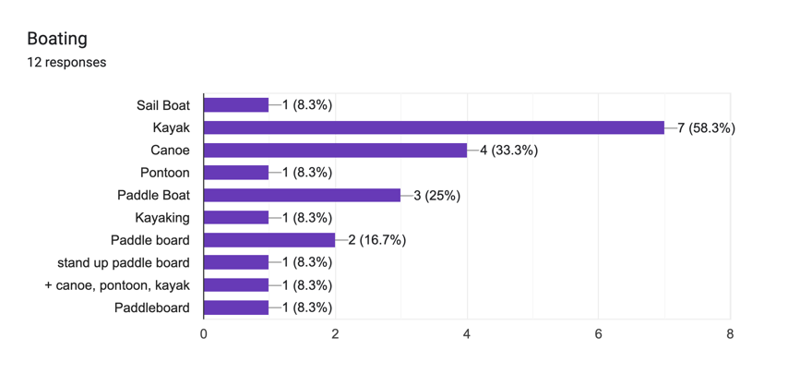
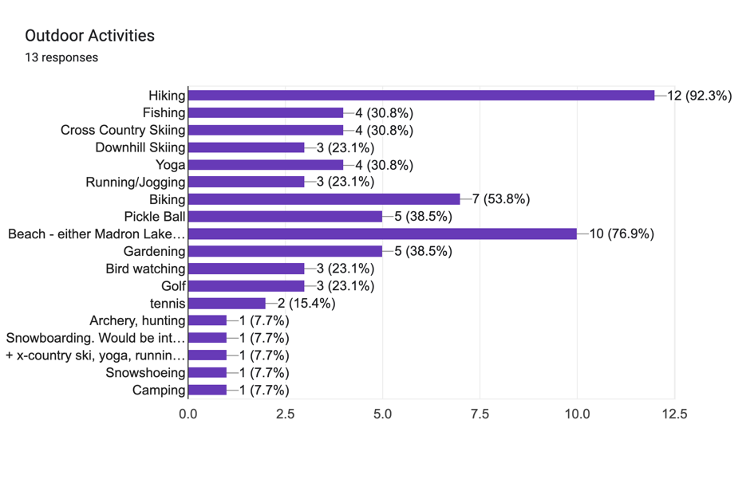
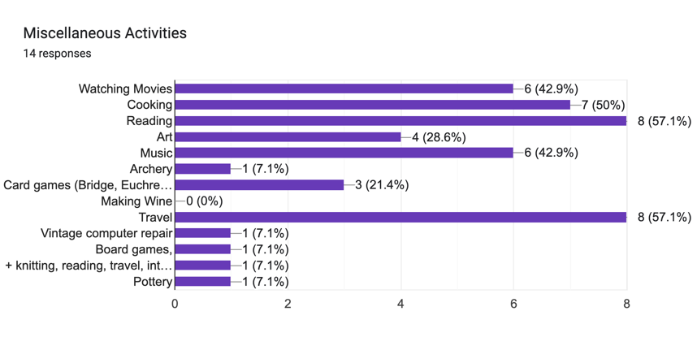
What are your favorite SW MI tourist destinations, museums? Parks?

Camp Madron, Warren Dunes, Mountain Bike areas - Andrews University and Chikaming, Meijer Botanical Garden (Grand Rapids), Saugatuck, Three Oaks, MI

What is your favorite Southwest MI Restaurant?

Terrace Room in the Harbor Grand Hotel in New Buffalo (especially in the winter), Red Arrow House, River St. Joe, Tabor Hill, Timothy’s, Houndstooth, Heston Supper Club, Susan’s, Carriage House, and Cameron’s.

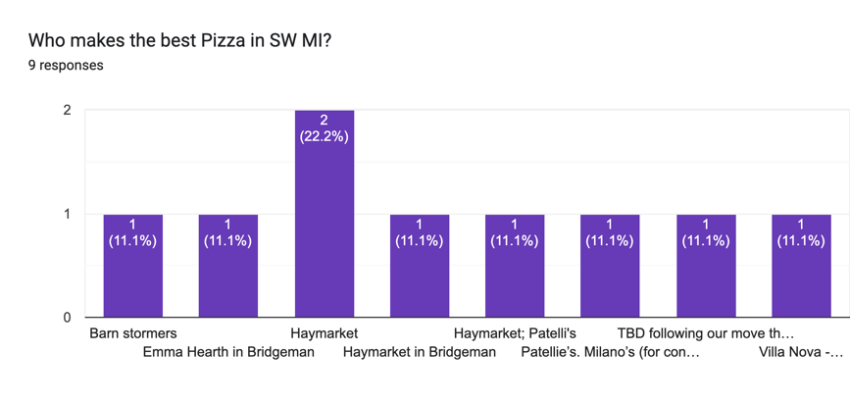
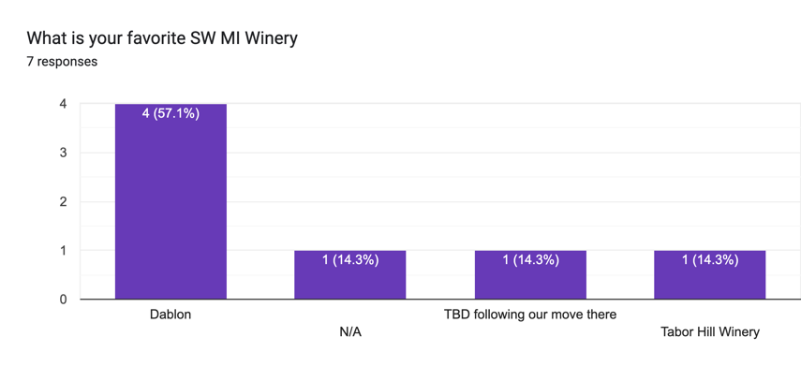

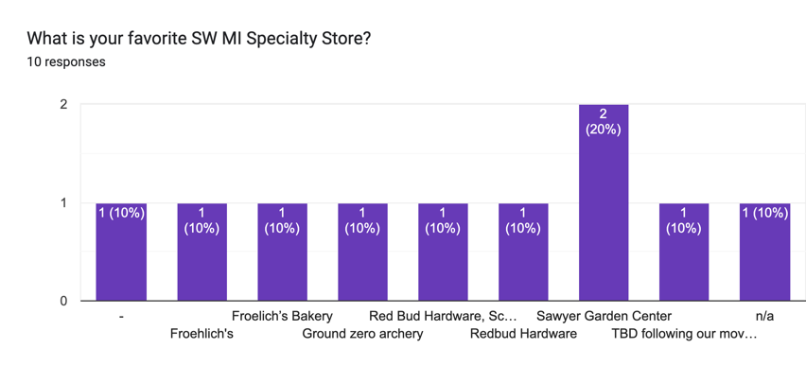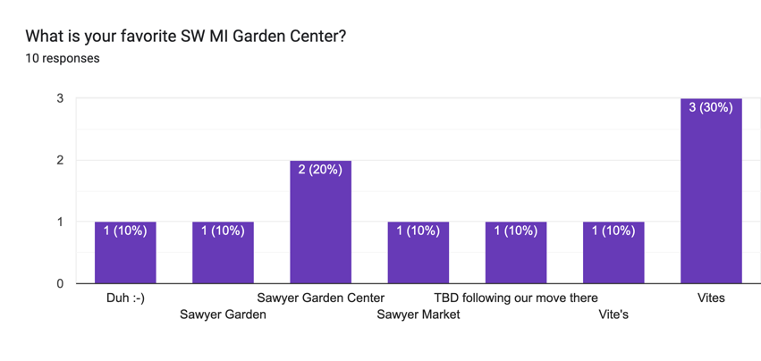
What is your favorite SW MI Grocery Store?
Meijer in Stevensville
Martins in Stevensville
Sawyer Garden Center
Barney’s in New Buffalo
Harding’s in Stevensville

What is your favorite SW MI Carry Out Restaurant?
Milano’s Pizza
Sawyer Market Indian Food
Round Barn Public House
Greenbush

What is your favorite SW MI Bakery?
Froehlich’s in Three Oaks
Gustavsen in Buchanan
Harbert's Swedish Bakery
Red Coach Donuts in Stevensville
Sandra Kay’s Bakery, Stevensville

What is your favorite SW MI Farmers Market?
Sawyer’s Market
Buchanan Farmer’s Market
Granor farm

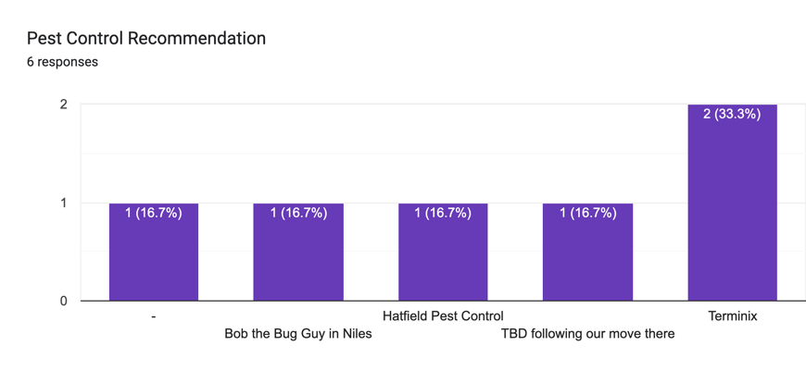
Painting Recommendation
Vaughn Geike 269-429-8296
Todd Latosinski 574-532-9010
Handsome Painting (Nick) 269-815-6328
Jimmie Wells (media blasting & staining)

Excavating and Driveway Recommendation
Kent Clark - KC Services

HVAC Recommendation
Michiana heating and cooling 574-234-9880
Vander Werf Energy 269-684-6429
Four Seasons 574-674-0841
Roberts Services (Chuck) 269-683-8549

Handyman
Bruce Kimball 361-7609
Andy Herrold 269-449-3746

Electrical Recommendation
Van der Werf 269- 684-6429
Wolverine Electrical 269- 683-4850
Kent Clark. 269-341-2007

Landscaping Company Recommendation
Creative Landscaping 269-473-1356
Miguel Vences 269-326-1223
Jeff Ammerman 574-514-0616
Vences Lawn Care 269-357-9209

Fireplaces, Chainsaws, and Gear Company Recommendation
Weldy’s for chain saw
Brothers Chimney Sweep

Water Softener Company Recommendation
Bauer Soft Water 269-697-7761
Mike Oates @ AIM 269-635-2857

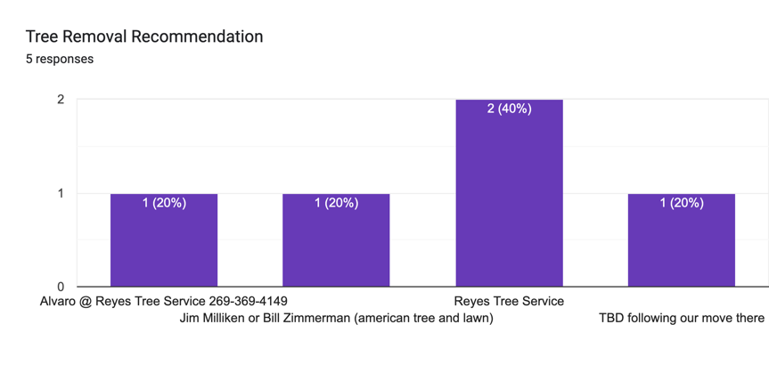

Roofing Recommendation
Mitch Sluder Construction - 269-208-6393
Nelson Stump Roofing 574-238-4696
Wee Bee Dunn construction 269-470-0607

General Contractor Recommendation
AVB Construction 269-323-2022
Andy Herrold . 269-449-3746
*not a licensed general contractor but can refer to all the subcontractors and/or direct them
Chris Hemminger 269-362-0925
Exquisite Homes of Michigan 269-471-5625

Window Washing Recommendation
Richard Scull- michianaunderpressure.com 269-357-1939
Tom Cabanaw- 574-250-4620
Michiana Cleaning Service 574-210-7652
Michigan’s Window Wizard 269-332-8619

Where do you go to purchase mulch?
Lowes
Vences Lawn Care (delivers) 269-357-9209
Culby's 269-944-1881
Redbud Hardware, Buchanan 269-695-6891

Where do you go to purchase gravel/stone?
Kent Clark 269-341-2007
Redbud Hardware, Buchanan 269-695-6891
Mark Farm & Home Supply 269-683-0598

Other - what other information would you like to share with your neighbors?
Infusco, Sawyer, MI for coffee
L&A Gutters: 269-208-2067
Falatics Meat Market, Sawyer, MI-delicious chicken polish and chicken italian sausages 😁

Please list recommended emergency vets, hospital, minute clinic.
Paws and Claws Kennel 269-473-3647
Pet Palace Resort & Spa in Granger 574-272-7387
Wellcott Farm on Warren Woods Rd 269-479-2010
Mullins Hardwood Floors 269-925-6925

